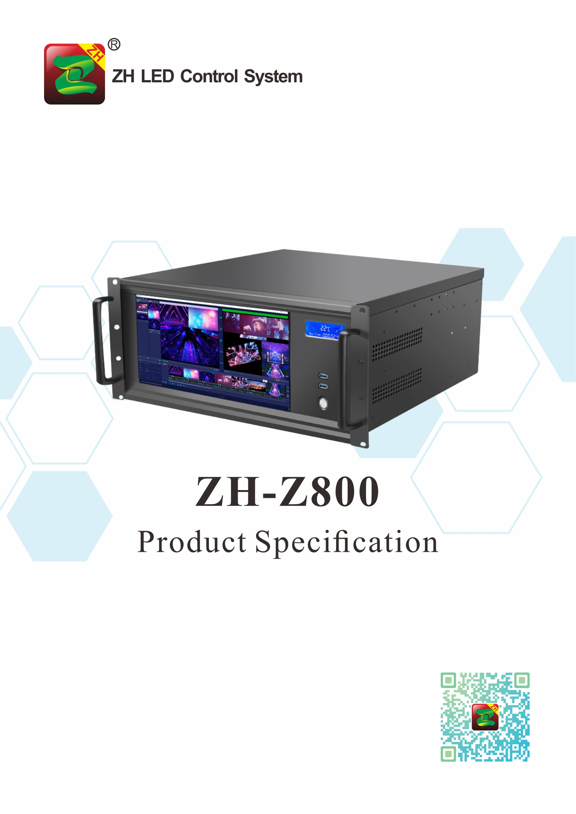

Product Specification
ZH-Z800
I. Product Introduction:

The Z800 video server is an integrated broadcast control server product, which produced by ZH for large LED screens in different application scenarios such as stages, bars, and conferences. It supports 4K×4 super-large resolution point-to-point display, which can be flexibly matched according to needs. Compared with traditional solutions, the cost is lower and the effect is better. At the same time, it can realize different scenes of video display and professional broadcast control functions, making customer management convenient, simple operation, and better application effects.

II. Functional Features

- Maximum support 4K×4 point-to-point display, flexible configuration and better solution;
- Support unlimited window opening;
- Support one-key switching of preset background pictures;
- Support audio output;
- Support program preview and display monitoring; 
- Support automatic identification or manual modification of the physical screen logical screen size;
- Support partition scene editing, preset, import and export;
- It supports direct switching of the display screen during broadcast;
- Support media classification: support all/video/picture/text;
- Support material custom label classification;
- Support batch import of media folders;
- Support material attribute adjustment: such as: position, size and angle, etc.;
- Support broadcast progress management;
- Support window level adjustment;
- Support hard decoding;
- Support one-click black screen;
- Support one-key lock to prevent accidental touch;
- Standard 5U chassis, more convenient to install and use.

III. Topology Diagram:

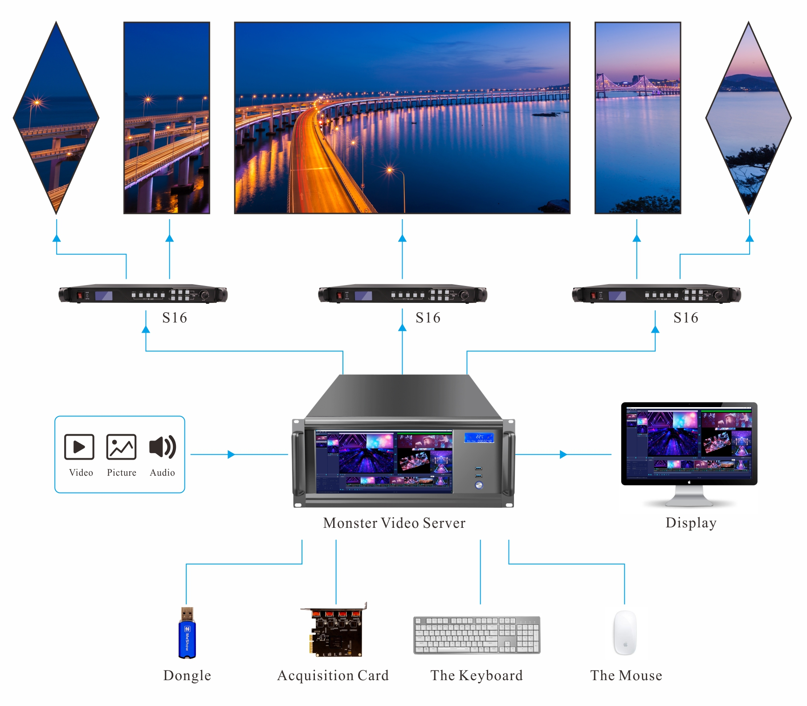

IV. Hardware Introduction:
The Front Panel
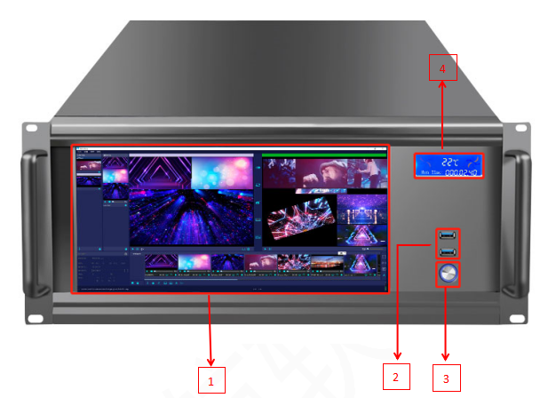
NO. | Name | Function
1 | Main Screen | Work as display screen, supports touch control
2 | USB Port | 2×USB 3.0, connect with the mouse, keyboard or USB flash drive, to import media files such as videos and pictures
3 | Button | Power on/off
4 | LCD Screen | Display device status: fan speed, chassis temperature, running time

The Back Panel

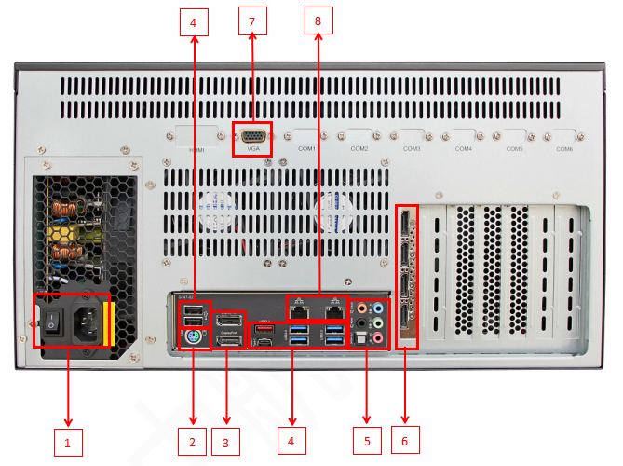

NO. | Name | Function
1 | Power on/off | 220V power port; power on/off
2 | PS/2 | 1×PS/2,  connect the PS/2 interface mouse and keyboard
3 | Display  Port | 2×DisplayPort。  Support resolution max 4096x2304@60 Hz  Support DisplayPort 1.2 version、HDCP 2.2 and HDR。
4 | USB | *1×USB Type-C；  *1×USB 3.1；  *4×USB 3.0；  *2×USB 2.0。  Connect USB interface devices such as mouse, keyboard, U disk, hard disk, etc.
5 | Audio Port | *1×MIC（Pink）：3.5mm Microphone audio input interface, connect to microphone and microphone;  *1×IN (Blue): 3.5mm external audio input interface, connected to external input equipment, input audio signal to the computer;  *1×OUT (green): 3.5mm audio output interface, main channel audio output, connect to headphones or dual-channel speakers;  *1×C/SUB (orange): 3.5mm audio output interface, connected to the center/bass channel of 5.1/7.1 multi-channel speakers;  *1×REAR (black): 3.5mm audio output interface, connected to 5.1/7.1 channel rear surround left and right channels;  *1×SPDIF: connect to optical fiber output.  Support High Definition Audio;  Support 2/4/5.1/7.1 channel;  Support S/PDIF output.
6 | Output Port | 4×DP 1.2 port  4pcs output interfaces, each port max support output: 3840×2160@60Hz
7 | VGA Port | Connect to the main screen on the front of the chassis
8 | LAN Port | 2×RJ-45。  Connect the Internet

V. Hardware Parameter

Chassis | Horizontal 5U, touchable HD monitor chassis
CPU | Intel,the 9th generation Core processor.
Motherboard | High-performance server-class motherboards.
Memory | 16G DDR4 High-speed memory,up to 128GB.
Storage | System disk: Samsung M.2 high solid state hard drive 256GB.  Storage disk: Samsung M.2 high solid state hard disk 512GB.
Graphics card | Quadro 5G, Professional graphics card.
Power | 600W server specialized power supply.
Operate System | Support Windows 10 64-bit
Note: Different batches,parameters changeable will not do any notice.
Thank you for your understanding.

VI. Support Media Format

Type | Format
Video | mp4、avi、mkv、mov、wmv、3gp、amv、asf、divx、flv、mpg、m2ts、rm、rmvb、m4v、ts、vob
Picture | bmp、jpg、jpeg、png
Audio | mp3、wav、aac

VII. Chassis Parameters

Power Input | AC 200~240V，50/60Hz
Temperature control | Support
Size | 482×450×222（mm）
Weight | 19.5KG

VIII. Hardware Diagram:

Unit: mm

